"Київський фаховий коледж зв’язку”
Циклова комісія комп’ютерної та програмної інженерії
ЗВІТ ПО ВИКОНАННЮ
ЛАБОРАТОРНОЇ РОБОТИ №2

з дисципліни: «Операційні системи»

Тема: «Знайомство з інтерфейсом та можливостями ОС Linux»

Виконали студенти
групи: КСМ-23а
Команда: The Awkward Turtles
Михайленко О.О.,
Трощинський Я.П.,
Когут Б.М.
Перевірила викладач
Сушанова В.С.
Київ 2024
Робота студентів групи КСМ-23а Команда The Awkward Turtles:
Михайленко О.О., Трощинський Я.П., Когут Б.М.

Лабораторна робота №2

Мета роботи:
1. Знайомство з інтерфейсами ОС Linux.
2. Отримання практичних навиків роботи в середовищах ОС Linux та мобільної ОС – їх графічною оболонкою, входом і виходом з системи, ознайомлення зі структурою робочого столу, вивчення основних дій та налаштувань при роботі в системі
Матеріальне забезпечення занять:
1. ЕОМ типу IBM PC.
2. ОС сімейства Windows та віртуальна машина Virtual Box (Oracle).
3. ОС GNU/Linux (будь-який дистрибутив).
4. Сайт мережевої академії Cisco netacad.com та його онлайн курси по Linux

Завдання виконував: Михайленко О.О.

Завдання для попередньої підготовки.
- CLI mode
СLI mode, or Command Line Interface mode, is a text-based user interface where users input commands in the form of text to perform specific tasks on a computer or server. Unlike graphical user interfaces (GUIs), which rely on icons and visual navigation, the CLI operates purely through text commands. It's commonly used in operating systems like Linux, macOS, and Windows, and provides more direct control over system operations, often preferred by developers and system administrators for its speed and precision.
- Graphical User Interface (GUI) terminal
A Graphical User Interface (GUI) terminal is a terminal emulator that allows users to interact with the system through both graphical elements and text commands. Unlike the traditional command-line interface, a GUI terminal provides buttons, menus, and other visual components that make it easier for users to execute commands and navigate without typing everything manually. These terminals typically simulate the functionality of a command-line interface while offering the ease of use associated with graphical environments.

- Virtual terminal
A virtual terminal is a software-based emulation of a physical terminal, allowing users to interact with a computer system or server over a network or locally without needing a physical terminal device. It provides access to a command-line interface or graphical interface remotely, often through protocols like SSH (Secure Shell) or Telnet. Virtual terminals are commonly used in server management, remote computing, and multitasking within operating systems, enabling multiple terminal sessions to run simultaneously.

Хід роботи.
1.1 Структура робочого простору Gnome та його основні компоненти.
1. Main menu:
This is the top bar on the screen that is always present:
On the left is the "Activities" button, which opens the activity view, which displays all open windows and running programs.
In the center there is a clock and a calendar and on the right are system indicators such as battery status, volume level, internet connection, and a button to log out or lock the screen.
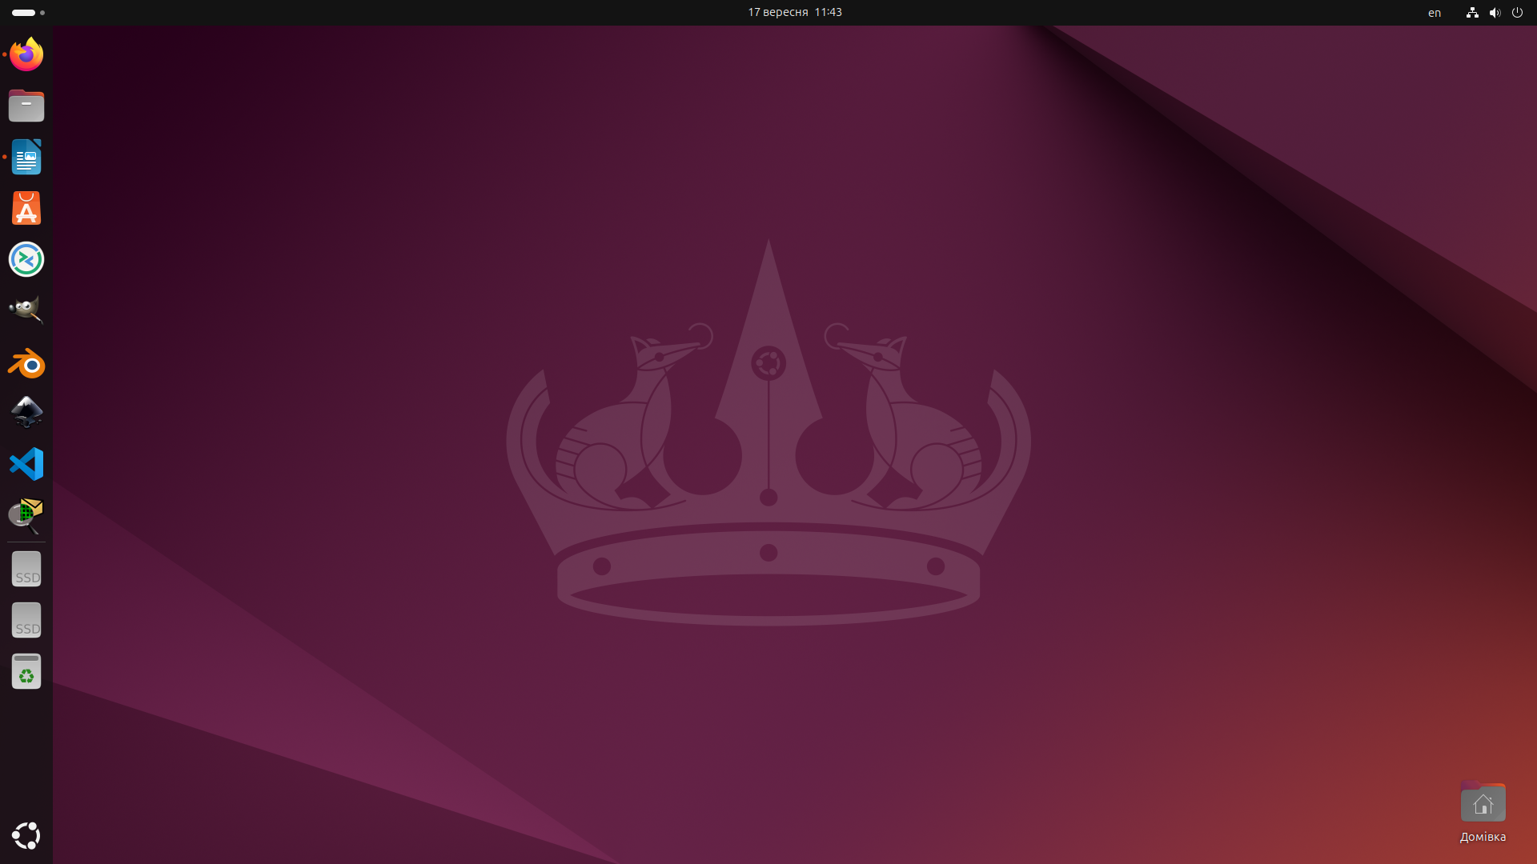

2. Quick access panels.
A vertical bar with application icons located on the left side of the screen(right of the text). It is used to quickly launch frequently used programs and switch between open windows.
3. Search.
A small button at the bottom left of the screen. When clicked, it opens the program installation window and allows you to search for the desired user programs.



4. Access to new desktops and more

One of the main components is the window opening panel. This component is located in the upper right corner of the screen. When clicked, all open windows are opened and an opportunity to remove or quickly change the window is provided.

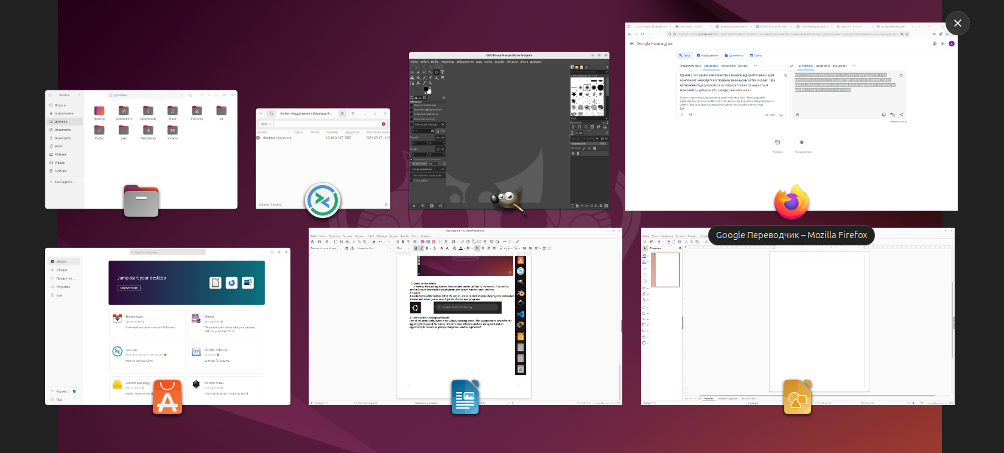

Завдання виконував Когут Богдан:
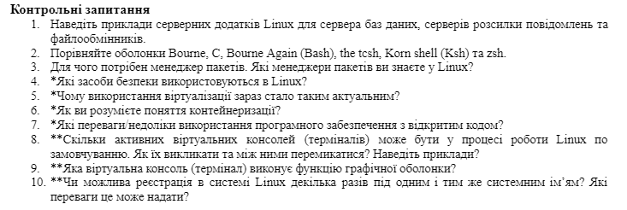Translated Questions:
- Provide examples of Linux server applications for databases, message servers, and file-sharing servers.
- Compare the Bourne, C, Bourne Again (Bash), tcsh, Korn shell (ksh), and zsh shells.
- Why is a package manager needed? Which package managers do you know in Linux?
- What security tools are used in Linux?
- Why has the use of virtualization become so relevant nowadays?
- Do you understand the concept of containerization?
- What are the advantages/disadvantages of using open-source security software?
- How many active virtual consoles (terminals) can be present during Linux operation by default? How to invoke them and how can you switch between them? Provide examples.
- Which virtual console (terminal) performs the function of the graphical shell?
- Is it possible to register in the Linux system multiple times under the same system name? What advantages can this provide?

Answers:
- Examples of Linux server applications for databases, message servers, and file-sharing servers:
- Databases: MySQL, PostgreSQL, MariaDB
- Message servers: Sendmail, Postfix, Exim
- File-sharing servers: Samba, NFS (Network File System), FTP servers like vsftpd

- Comparison of Bourne, C, Bourne Again (Bash), tcsh, Korn shell (ksh), and zsh shells:
- Bourne shell (sh): The original UNIX shell, simple and basic scripting.
- C shell (csh): Adds C-like syntax and job control.
- Bourne Again Shell (bash): Popular, extends Bourne with more scripting capabilities.
- tcsh: A C shell derivative, with enhanced features like command completion.
- Korn shell (ksh): Powerful, combines features of both Bourne and C shells.
- Z shell (zsh): Highly customizable, combines features of Bash, ksh, and tcsh.

- Why is a package manager needed? Which package managers do you know in Linux?
- A package manager simplifies the installation, update, and removal of software on Linux. It manages dependencies and ensures that packages work together smoothly.
- Examples: APT (Debian/Ubuntu), YUM/DNF (Fedora/RedHat), Pacman (Arch Linux), Zypper (openSUSE)
- What security tools are used in Linux?
- SELinux: Provides mechanisms for enforcing security policies.
- AppArmor: A kernel security module for restricting program capabilities.
- iptables/nftables: Firewall software for controlling network traffic.
- ClamAV: Open-source antivirus software.

- Why has the use of virtualization become so relevant nowadays?
- Virtualization allows for better resource utilization, isolating workloads, easier scalability, and lower costs. It also simplifies testing and deployment.

- Do you understand the concept of containerization?
- Yes, containerization packages applications and their dependencies in isolated environments called containers. It ensures that applications run consistently across different environments.

- What are the advantages/disadvantages of using open-source security software?
- Advantages: Transparency, cost-effectiveness, and community-driven support.
- Disadvantages: Possible lack of formal support, requiring in-house expertise.

- How many active virtual consoles (terminals) can be present during Linux operation by default? How to invoke them and how can you switch between them? Provide examples.
- Typically, Linux has 6 virtual text consoles and 1 graphical console. You can switch between them using Ctrl + Alt + F1 to Ctrl + Alt + F6 for text, and Ctrl + Alt + F7 for the graphical interface.

- Which virtual console (terminal) performs the function of the graphical shell?
- Typically, the 7th virtual console (Ctrl + Alt + F7) is used for the graphical interface.

- Is it possible to register in the Linux system multiple times under the same system name? What advantages can this provide?
- It is generally not allowed to have multiple simultaneous logins with the same name, but certain mechanisms like user namespaces allow similar behavior, which can help with isolation and resource control.

Форматування документу виконував Трощинський Ярослав

